Linux lab-3

k.hema anmisha

17mis1059

1. Searching for a word in a file by using grep command

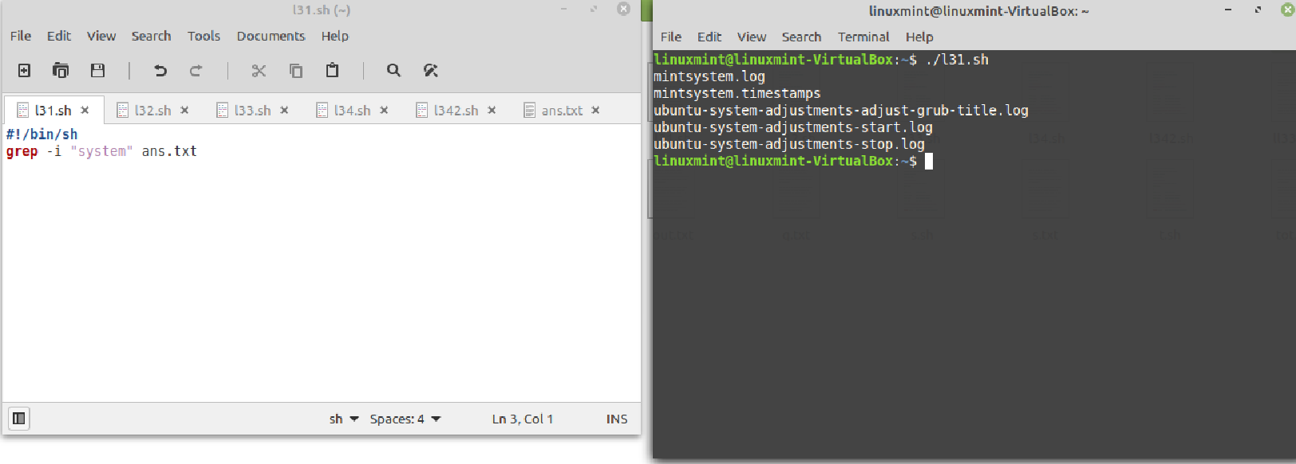

Searching for a word in a file without using grep command

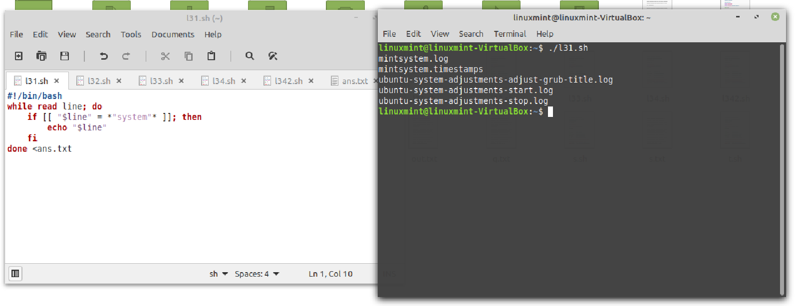

1. Reading the file using the while loop and searching for a word

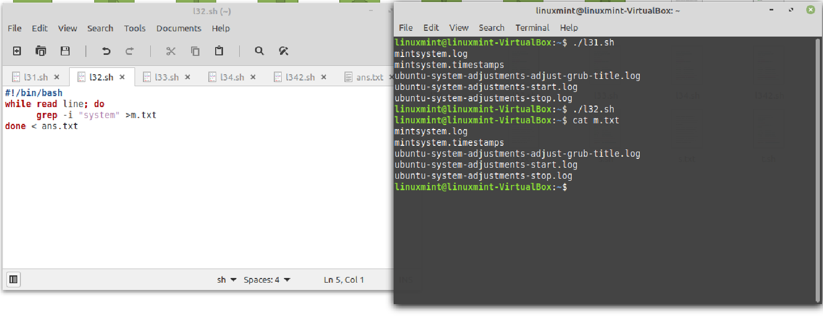

1. Searching for the errors in the log files and printing them for every half an hour

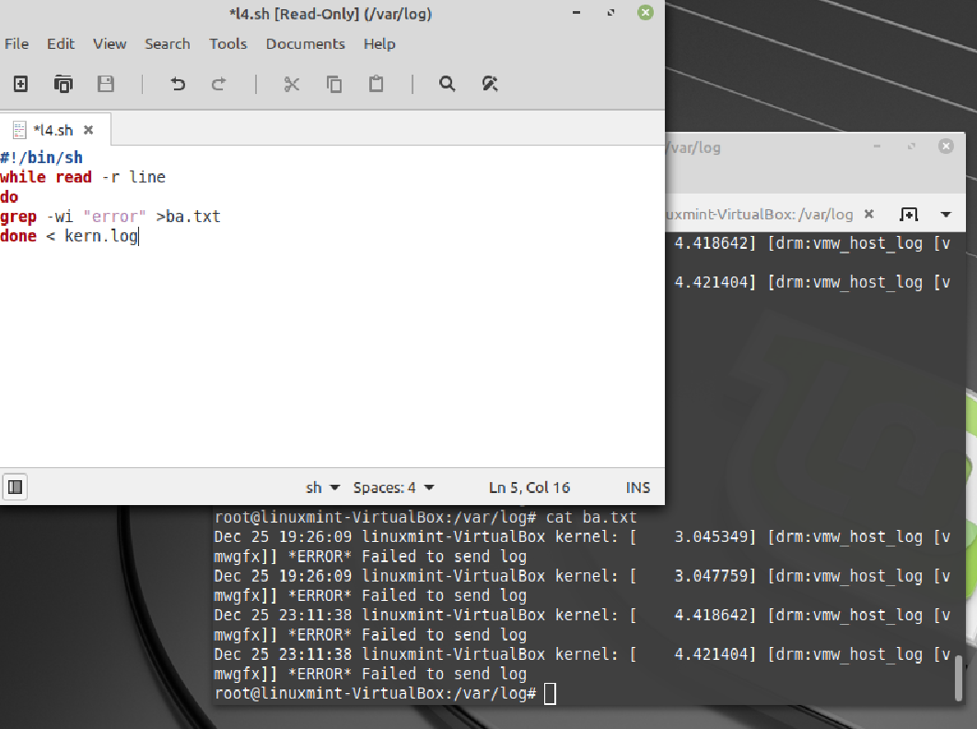

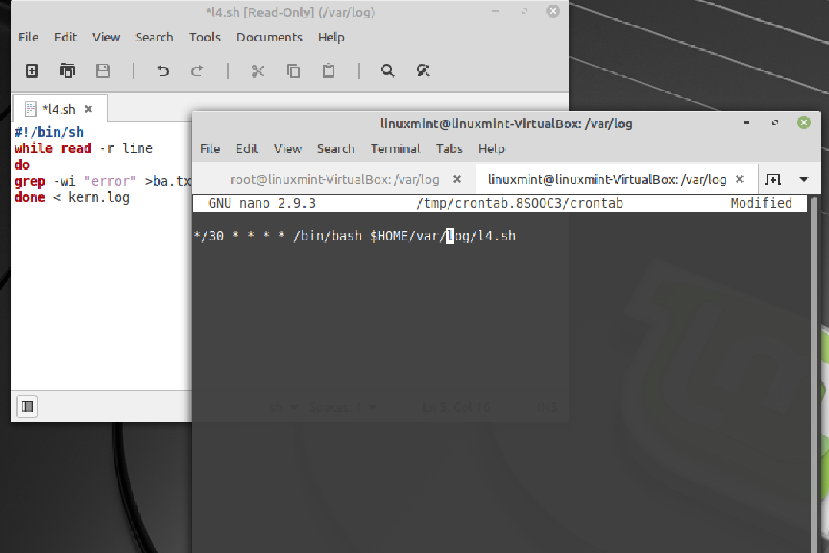

1. Measuring the performance of a process using the top command, for every minute to printuse(\*/1 \* \* \* \*)

